**Progress update on the simulation model for the hake MSE**

**Overview of the MSE simulation model**

Management strategy evaluation (MSE) investigates the performance of management procedures in the face of uncertainty (Figure 1). Our MSE model can be divided into four parts: 1) an operating model (OM) that simulates the dynamics of a population and the fisheries 2) data generation from the OM, 3) an estimation model (EM) performs a stock assessment based on the data generation, 4) a harvest control rule is applied based on the output from the stock assessment. Finally, the process is repeated and the operating model is updated for the following year based on the catches specified by the harvest control rule.

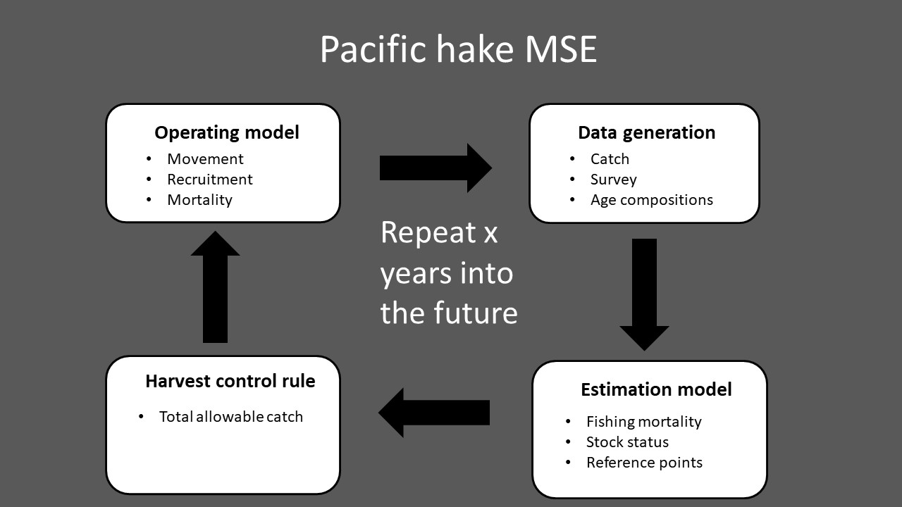

Figure 1: Conceptual overview of the Pacific hake management strategy evaluation (MSE).

**Progress on model development and testing**

* Estimation model testing and improvements
  + Code debugged and tested
  + Fixed previous issues with estimation model not converging and not being able to estimate uncertainty (non-identifiable Hessian)
* Operating model testing and improvements
  + Added option to explore future scenarios with simplified catch metrics, enabling quick sensitivity analysis of OM parameter assumptions
  + Added option to “turn-off” movement for sensitivity analysis and comparison to previous coastwide MSE simulation model
  + Added parametric function to describe how movement changes with fish age (Figure 2). This will allow faster sensitivity testing to assumptions about movement rates by reducing the number of parameters describing movement.
* Completed code to conduct full closed loop simulation
  + Completed code to calculate performance metrics as defined by JMC
  + Ran initial projections (see Figure 3 for examples)
  + One 50 year projection takes approximately 5 minutes

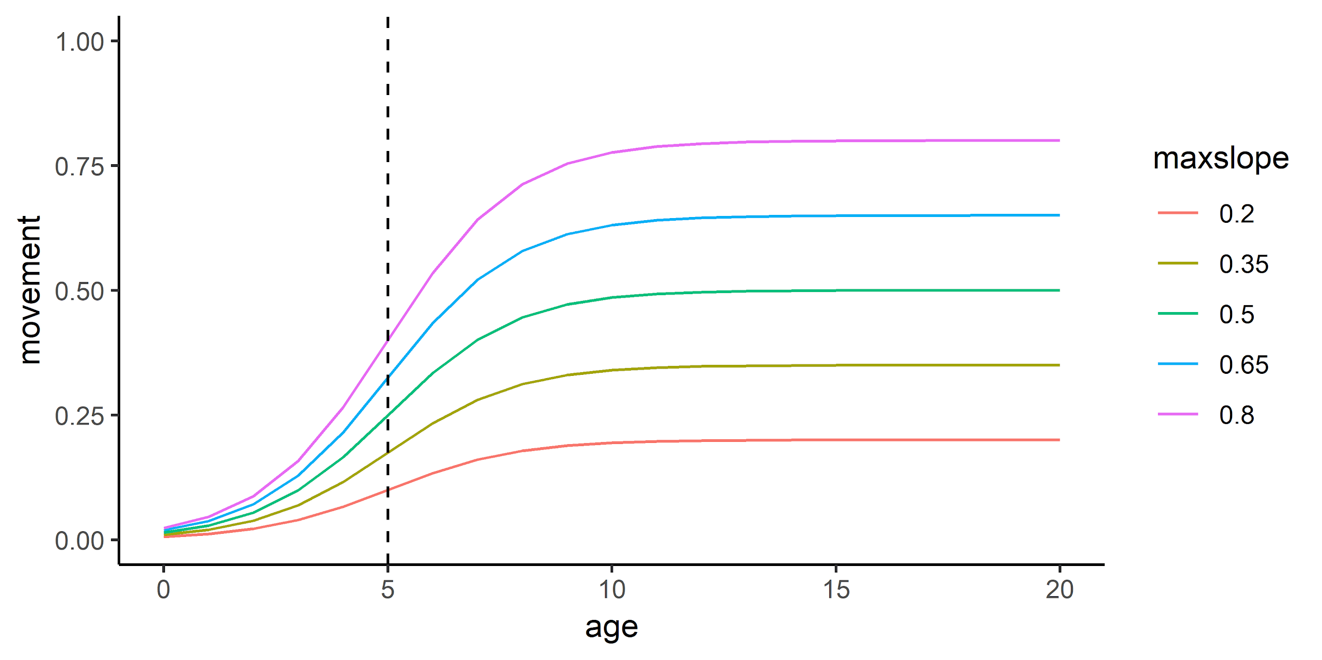

Figure 2: Examples of movement in the operating model. Colored lines denote max movement rate, and vertical dashed line denotes the age at 50% of maximum movement rate.

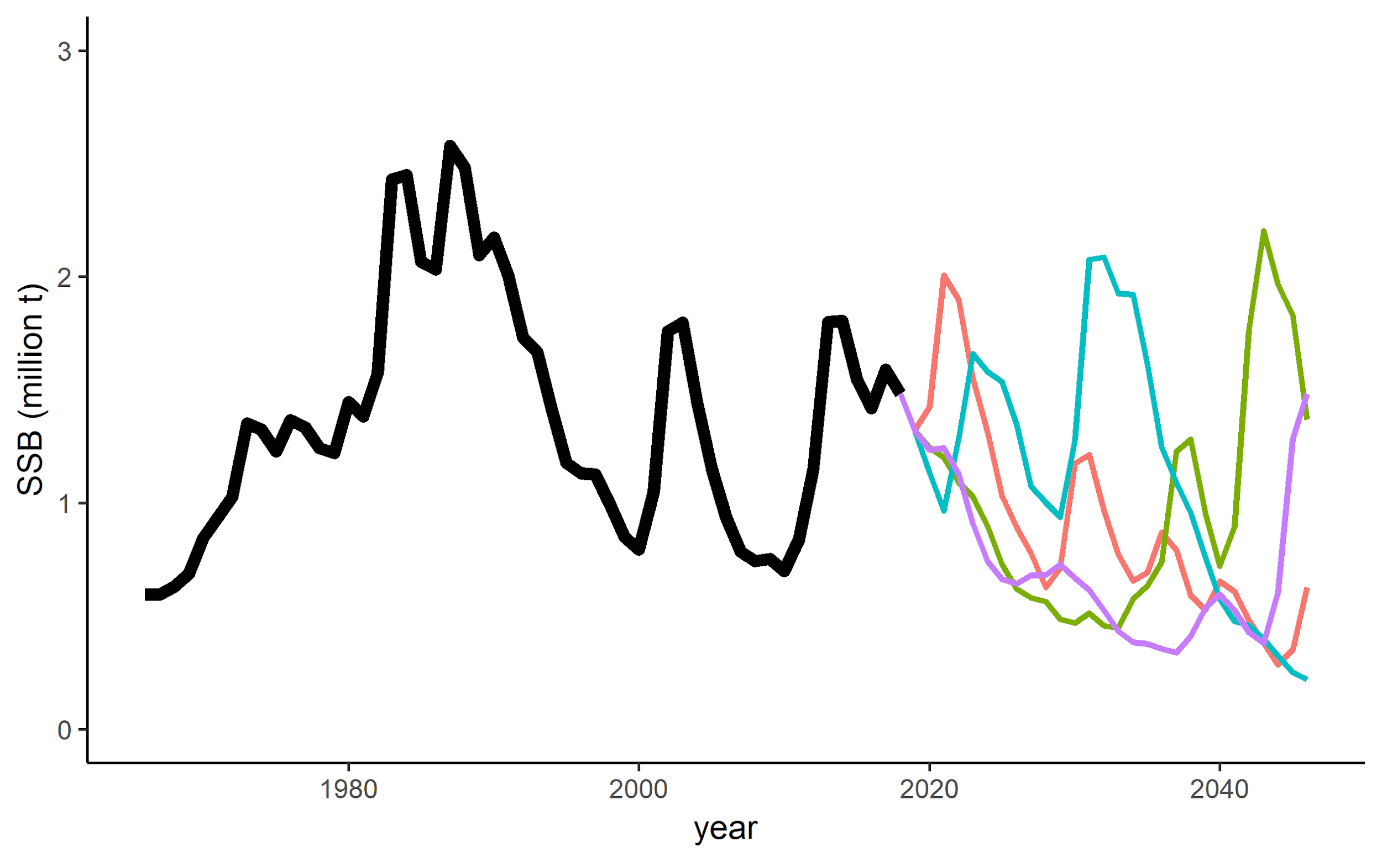

Figure 3: Spaghetti plot of four example projections, assuming full utilization of the total allowable catch, and maximum movement rate of 0.5.

**Datasets currently used for model conditioning**

* Fisheries independent survey index of abundance. Spatially explicit (starting in year 1995).
* Fisheries independent survey age compositions in Canada and the US in survey years (Figure 4)
* Fisheries catch in Canada and the US
* Fisheries age composition in Canada and the US

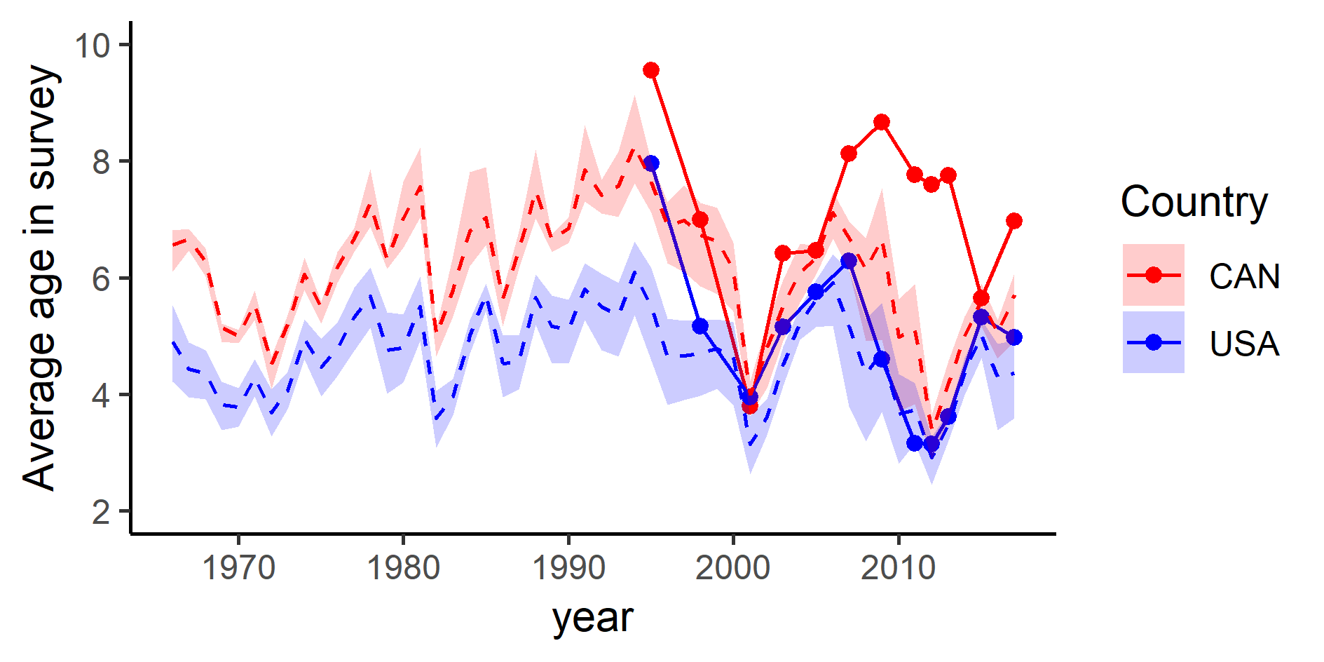

Figure 4: Average age from the fisheries independent survey. Dashed line indicate mean output from the operating models using the maximum movement rates from figure 2. Shaded area indicate the minimum and maximum values. Solid dotted lines are data from the survey.

**Planned activities before SRG meeting in February:**

* Perform simulations with varying movement parameters within the MSE framework
* Compare performance metrics in the MSE with movement enabled/disabled
* Investigate sensitivity of performance metrics to movement parameters

**Discussion questions:**

* Which simulations should be prioritized for the December/February meetings (e.g., a range of movement rates, harvest strategies or recruitment scenarios)?
* Are the movement assumptions reasonable?
* Suggestions for OM conditioning and future simulations?

Appendix: Operating model structure, as presented to JMC in August 2017

**Operating model**

The core of the operating model is a standard age based model with a latitudinal spatial structure. The model has been implemented as flexible software to investigate a range of potential operating model configurations, such as number of spatial grid cells, timescale, temporal movement, and spatial and time varying selectivity. Initial model runs have been explored based on few core assumptions listed below:

* Timescale: initial years (1965-2018) + 35 years into the future. Runs 4 seasons per year. Recruitment occurs in season 1.
* Current spatial structure assumptions:
  + 2 boxes
  + Initial distribution of 75% percent of the stock in the southern area and 25% in the northern area.
  + Stock-recruitment is area dependent, but has the same productivity parameters
* Generates fishery data every year (total catch and age compositions), survey data every second year in the future (survey index of abundance and age compositions)
* Age based movement parameters each season
  + Recruits and 1 year olds do not move
  + Movement rate is modeled as the fraction of the numbers at age that leave an area
  + Movement rates are modeled as a logistic function of age with 3 parameters (maximum movement rate, slope of movement rate and the age at 50% of maximum movement) (Figure 3).
  + Most spawning individuals migrate south and spawn in the last season of the year
  + During the year, fish rarely move south.
* One “fleet” in each area (country) and Ggear selectivity is constant within each area, but with possibility to be time varying

* Software designed to be flexible to allow multiple operating model configurations to capture a range of possible dynamics of the population and the fishery. Operating model runs in the R environment.

**Summary of current state of the MSE closed loop simulations:**

* Fully operational closed loop
* First iteration of operating model
* Flexible OM and EM allowing for comprehensive sensitivity analysis of parameters and assumptions
* New software implementation allows much faster (greater than 10x) running time than MSE approach used in the past, in spite of the additional complexity in the spatial and seasonal Operating Model.

On call:

NWFSC

Kristin Marshall

Kelli Johnson

Nis Jacobsen

JMC

Frank

Dan Welbeck

Bruce

Barron?

JTC:

Ian Taylor

Chris Grandin

Sean Cox

Aaron Berger

AP

Mike Okanowski

Shannon

Dave Smith

Teresa

Call notes:

First go through objectives document (sent around by Paul)

* 1. Objectives now have hierarchies
  2. Let paul talk about objective 3 and 4

Rob (DFO MSE coordinator I think) revised the new objectives in the table. Do we want both objectives 2 and 3 (years SSB is under 40% and consecutive years it’s under 40%).

Frank: Remember this is a call on MSE and not a formal JMC meeting.

Kristin:

Dan: We can meet in a more formal meeting and discuss the specific meeting. Note that the objectives claim that recruitment is impaired at B40.

Sean: There is a point where recruitment starts to decline (depending on steepness).

Ian: Steepness is 0.79. SR is pretty much a shotgun blast.

?: When SSB is 20% then you get 80% of recruitment.

Kristin: We can change the set of references, if we want to look at some other objectives than recruitment.

Paul: We should set some time aside to discuss the objectives. Suggest a call on the objectives.

Sean Cox: Look at the thresholds (e.g., 40% or 20%).

Mike: Are we gonna have a meeting about the consequences for fishery lock down..

Frank: What is the timing of all this? I can’t participate in calls within the next week to 10 days. Time to november 13th to 16th.